

ARDUINO DISTANCE MEASUREMENT

|  |  |
| --- | --- |
| Name: | Muhammad ‘AtiqulHakim Bin Mohd Ramli |
| Student ID: | DE96562 |
| Submission Date: | 18 December 2020 |
| Assignment: | Final Class Project |
| Subject Code: | EEED253 |
| Academic Year: | Semester 1 2020/2021 |
| Course Instructor: | Dickson Neoh Tze How (dickson@uniten.edu.my) |

Table of Contents

**Chapter 1** 2

1.1 Abstract 2

**Chapter 2** 3

2.1 Introduction 3

2.2 Component 4

2.2.1 Ultrasonic Distance Sensor HC-SR04 4

2.2.2 Arduino UNO REV3 5

2.2.3 Liquid Crystal Display (LCD) 16 by 2 Green Version 5

2.2.4 Passive Infra Red Sensor 6

2.2.4 Light-Emitting Diode 6

2.2.4 Piezo Buzzer (Beep Sound) 7

**Chapter 3** 8

3.1 Methodology 8

3.2 Flowchart 13

3.3 Program Code 14

3.4 List of all component 15

3.5 Circuit Diagram 16

**Chapter 4** 17

4.1 Results and Discussions 17

4.1.1 Result 17

4.1.2 Discussion 20

**Chapter 5** 22

5.1 Conclusion 22

References 23

# **Chapter 1**

## 1.1 Abstract

This project is designed a device to economic or small sector especially that want to measure items or to ensure the social distancing between the person with correctly. This project also solves many problems from the owner market that say very hard to always check a social distancing when customer line up at the counter. To solve both problems, I had used an Arduino UNO as the main component by using an ultrasonic sensor and PIR Sensor. Arduino UNO board will make smoothly to look a distance and can minimize the parallax which means some measurement error when the owner reads a scale form the wrong position. To get distance calculation correctly, it can be solved only using the right formula to get the distance in centimeter and meter unit. This measurement technique provides an effective means of accurately measuring small distances. This device proposes the idea of fast and efficient counting the distance without any measurement tools.

# **Chapter 2**

## 2.1 Introduction

Today's global economy offers various adventures in every sector. In each sector, small requirements are essential for the development of major measures, including occurring new normal for today, required for all economic sectors to practice a social distance of at least 1 meter. By using different resources, we can modify them according to our specific needs and apply them in different areas. Measurement usually takes place through a measuring instrument in the early years. However, the digital transformation may be as strong as possible in the future [1].

Next to the older measuring tool like figure 2.1 is just having a body and tape measure. After that, the last measurement tools also like this, but the developer makes it change to the body by putting the LCD screen to read a distance as shown in figure 2.2. Otherwise, another measurement has many changes which have only the LCD display and laser function to take the distance as shown in figure 2.3.

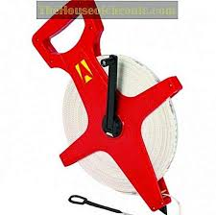

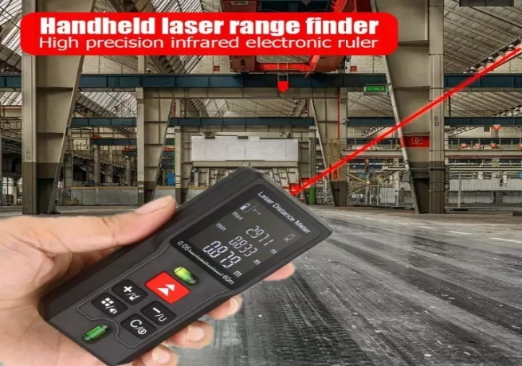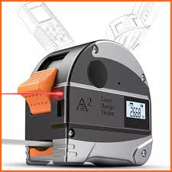

Figure 2.1 Wheel measurement Figure 2.2 Electronic measurement Figure 2.3 Laser Rangefinder

Using the Arduino UNO board, I can construct a measuring system and use a specific display unit to measure the distance, especially the centimeter (cm) and the meter (m). And then also used ultrasonic sensor HC-SR04 connected with Arduino UNO in this distance measurement device. To calculate a distance, I used an ultrasonic sensor by connecting with an Arduino UNO board because I can use the ultrasonic waves from the echo pin and trigger pin in the ultrasonic sensor and transform this sound wave to the computation of units, such as distance. This generates a 40k Hz ultrasound, which passes through the air and bounces back into the module, whether it has an object or an obstacle. I can calculate the distance based on travel time and sound velocity [2].

To produce an ultrasound for detection, the trig pin Ultrasonic board must be placed in a high condition when writing the code. It would send an 8-cycle sound pulse that will move through the sound waves and receive into the echo pin at the Ultrasonic board.

## 2.2 Component

### 2.2.1 Ultrasonic Distance Sensor HC-SR04

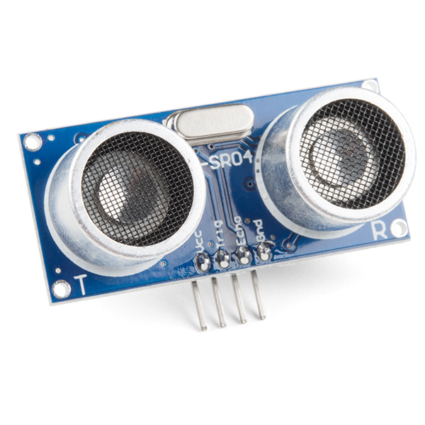

Figure 2.2.1

It produces between a 40 kHz – 250 kHz ultrasound, which is moves in the air and if there is something on the way and will return to the module. The Ultrasonic Sensor can catch up or detect from 2cm until 400cm [3]. By using Ultrasonic sensor, I can compute the distance by considering or watching the time and sound waves.

### 2.2.2 Arduino UNO REV3

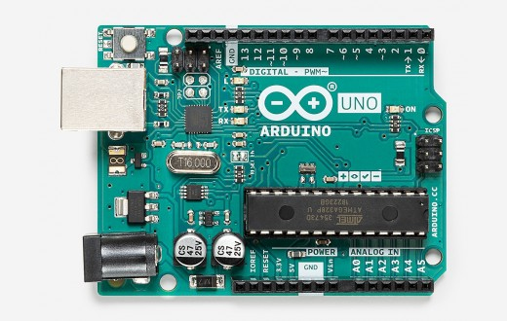

Figure 2.2.2

Arduino UNO is a unique microcontroller board because it has 14 digital I/O pins and six analog inputs, 16 MHz resonators, a USB port for computer connection, DC input, reset button.

It contains all the necessary parts to support the board, simply connect a computer using a USB cable, or can use an AC-DC adapter or a 7 – 12V battery to start an Arduino UNO [4]. I use this version of Arduino UNO REV3 because to program and send code.

### 2.2.3 Liquid Crystal Display (LCD) 16 by 2 Green Version

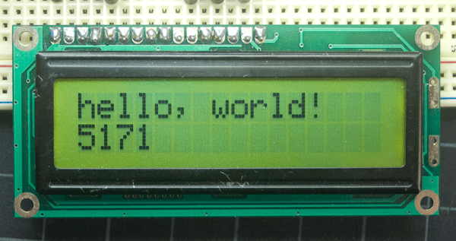

Figure 2.2.3

The Liquid Crystal Display (LCD) 16 by 2 Green Version is an electronic board display device. A Liquid Crystal Display (LCD) 16 by 2 Green Version is a basic module and is generally used in different appliances and circuits. The reasons for LCD can easily be programmed, and the characters, including personalized characters, are not limited unlike seven segments [5]. I select this LCD because to Inform user by presenting result total measurement using Liquid Crystal Display (LCD).

### 2.2.4 Passive Infra Red Sensor

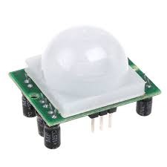

Figure 2.2.4

Passive Infrared Sensor or PIR sensor will notice the action of obstacles or object that through in their hotspot. For the operate of the PIR sensor, once an object like humans or animal's bodies through the sensor that may reflect IR light, the output pin price of the PIR sensor will change from low to high or zero to 1. PIR sensor can make detection range humans moving around 10m from a sensor only.

### 2.2.4 Light-Emitting Diode

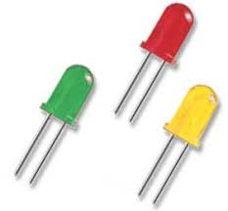

Figure 2.2.5

I used three colors of Light-Emitting Diode (LED) that are yellow, green, and red. For yellow LED it will be turned on when the PIR Sensor in the low state which is for make measurement in centimeter(cm) unit. For green light will be turned on when PIR Sensor in a high state which is for making social distancing measurement. Otherwise, when metering measurement more than 100cm or 1m, the red light and green light will be turned on and the buzzer will be generated a beep sound. The unregulated current can quickly give out the LED. The resistance is often any worth between 100 Ohms until 10k Ohms. Lower value resistors will enable additional current to flow, which makes the LED brighter. If I do not put the resistor parallel with the cathode, which makes the LED damage.

### 2.2.4 Piezo Buzzer (Beep Sound)

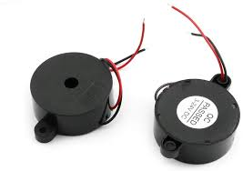

Figure 2.2.6

The function of the piezo buzzer is it can produce a good beep sound and tones at a certain value. They use a piezo crystal with changes form when pressure was applied to it. To understand whether this social distance is more than or equal to one meter, I used this piezo buzzer.

# **Chapter 3**

## 3.1 Methodology

First of all, because I was used the main component in this project is Ultrasonic Distance Sensor and Passive Infrared Sensor (PIR Sensor). I will explain how it does work in this project using an Arduino UNO.

First, Ultrasonic Sensor has four main pins on the board which is Vcc (+5V), Trig (Input pin), Echo (Output pin), Ground (GND). Everything is very important to connect the GND and Vcc pins on the Ultrasonic board to the GND and 5-volt pins in the power pin segment on the Arduino UNO board respectively. For the Trig and Echo pins in any digital Input/Output on the Arduino board. Users must set the trig for 10 μs to a heightened level to generate the ultrasound. That is sending out an 8-cycle harmonic blast that will be going to drive at the speed sound and be received in the Echo pin. The Echo pin provides the time a sound wave is traveled in microseconds. To begin, with an example, the target is 8 cm from the sensor and the sound speed is 0.034 cm/μs, then calculate the time using the formula which is the distance divide by speed, and I get the answer 234.3μs. The total that I receive from the Echo pin is a double value because the ultrasonic sound wave sensor moves in the reflection that is ahead and back. Consequently, we must multiply by 0.034 the travel time obtained by the echo pin and divide it by 2 to reach the range in centimeter [2].

To construct this project is very easy and advantageous if you are using the Arduino UNO equipment. In this chapter, I will explain to you how to build this project:

1. 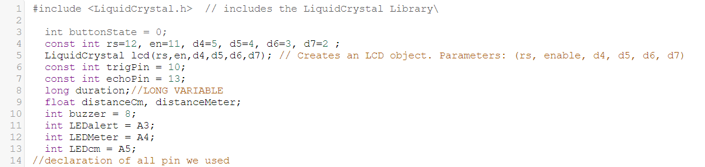

Figure 3.1

Line 1: First thing to do, we must program the Liquid Crystal Library using the libraries.

Line 3: Declare the initial signal state of the PIR Sensor.

Line 4-5: Declare all pins that I was used in 16x2 LCD to communicate with Arduino UNO.

Line 6-7: Declare trig and echo pins of Ultrasonic Distance Sensor to make communication.

Line 8-9: Declare the result get from echo and trig pins to became in decimal point because in measurement is very important to have decimal point to make it more accurate.

Line 10-13: declare the all-important component that used in this project is a piezo buzzer, red LED, green LED, and yellow LED.

1. 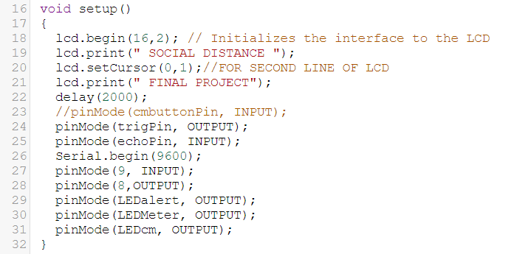

Figure 3.2

Line 16: This is for generate only once of my starts program.

Line 18: Initializes the interface to the LCD screen and specifies the width a d height of the display.

Line 19-21: Print the character in LCD at first line and second line.

Line 24-31: declaring all pins either execute became input or output.

1. 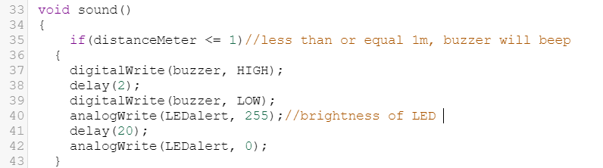

Figure 3.3

Line 34: This scope will use for the buzzer subroutine

Line 36: It will execute only when the Ultrasonic Distance Sensor measures less than or equal to one meter.

Line 38-40: Buzzer will be out the beep sound and then delay for 2ms (millisecond) before it will off.

Line 41-44: Red LED will turn on at high brightness when the beep sound is implemented.

1. 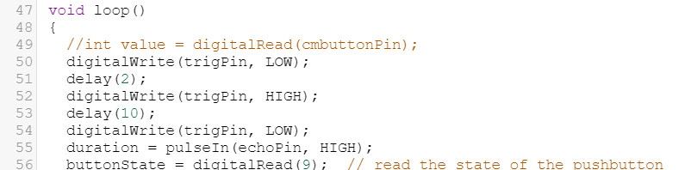

Figure 3.4

Line 47: This scope will implement all things with consecutively.

Line 50-53: From figure 3.4, I also should set the pin to a LOW state for 2ms delay. For next, I should set the Trig pin to a HIGH state for 10 ms delay to initiate an Ultrasound wave

Line 55: Pulse will read either is a HIGH or LOW condition.

Line 56: this for check the button state of PIR Sensor either in active high or low condition.

1. 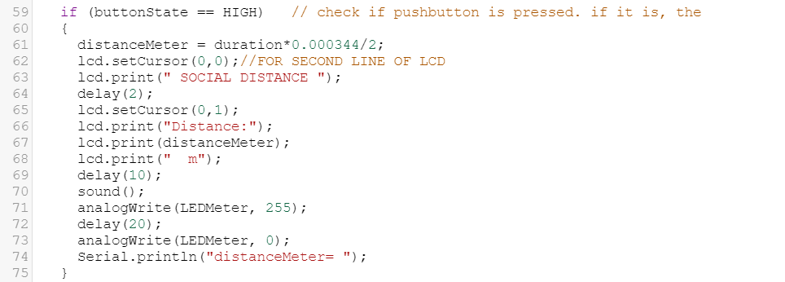

Figure 3.5

Line 59: If the button state or PIR Sensor sensing human or animals it will implement this part.

Line 61: Calculate the distance in meter unit.

Line 63-69: Using the reference on the Arduino website, the print() function will print anything based on what we write on the LCD. To write the code using the print() function. The result will show in the second line while for the first line shown “SOCIAL DISTANCE".

Line 71-74: If this device or coding reads the social distancing, the green LED will be turn on.

1. 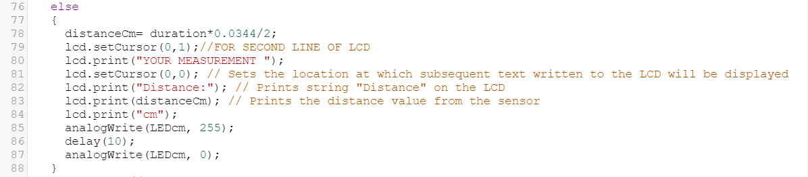

Figure 3.6

Line 76: If the button state or PIR Sensor did not sense humans or animals it will implement this part.

Line 78: Calculate the distance in meter unit.

Line 79-84: Using the reference on the Arduino website, the print() function will print anything based on what we write on the LCD. To write the code using the print() function. The result will show in the first line while for the first line shown “YOUR MEASUREMENT".

Line 85-87: If this device makes a measurement, the yellow LED will be turn on.

## 3.2 Flowchart

Figure 3.5 Flowchart for Arduino Distance Measurement

## 3.3 Program Code

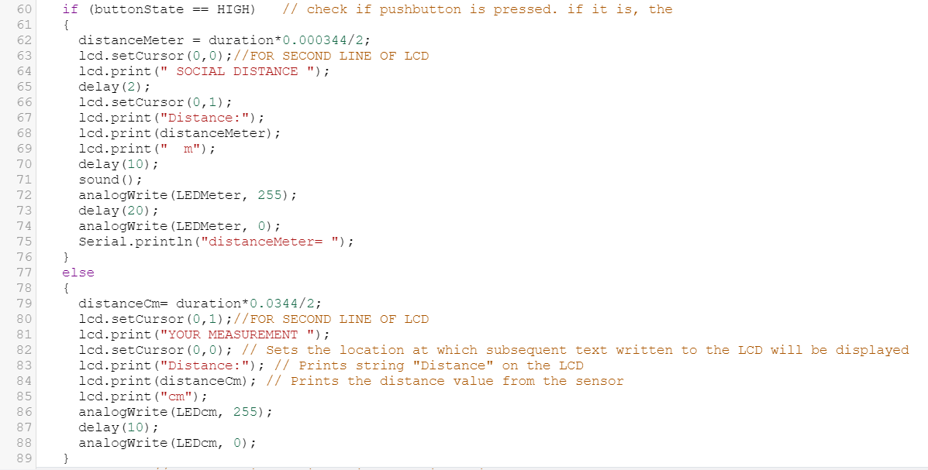

Figure 3.6 Important part in program code for Arduino Distance Measurement

## 3.4 List of all component

Figure 3.11 table list of all component

|  |  |  |
| --- | --- | --- |
| **Name** | **Quantity** | **Component** |
|  |  |  |
| U1 | 1 | Arduino Uno R3 |
| U2 | 1 | LCD 16 x 2 |
| DIST1 | 1 | Ultrasonic Distance Sensor |
| R1 R3 R4 R5 R6 | 5 | 330 Ω Resistor |
| R2 | 1 | 1 kΩ Resistor |
| PIEZO1 | 1 | Piezo |
| PIR1 | 1 | PIR Sensor |
| D1 | 1 | Yellow LED |
| D2 | 1 | Green LED |
| D3 | 1 | Red LED |

## 3.5 Circuit Diagram

Figure 3.7 Schematic of Arduino Distance Measurement using Thinker CAD

# **Chapter 4**

## 4.1 Results and Discussions

### 4.1.1 Result

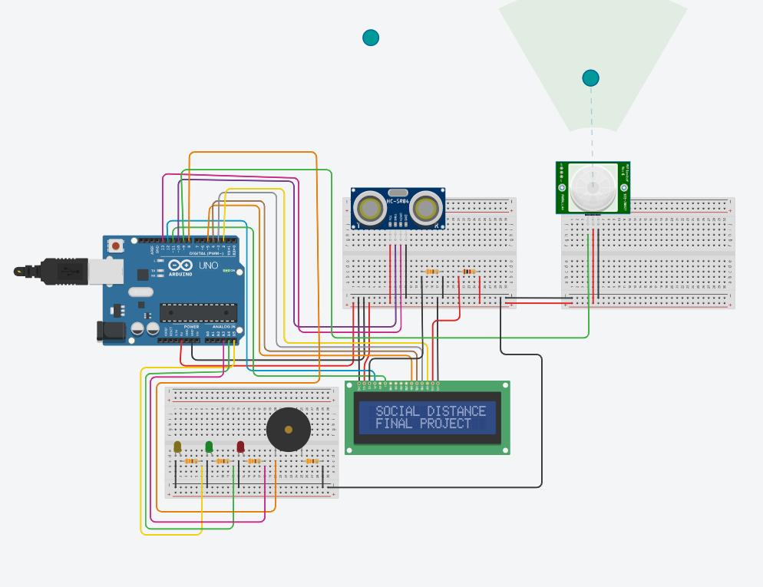

#### Figure 4.1.1 Initial condition when starting the program code

#### When Arduino UNO is connected to a power supply, the LCD will show like in figure 4.1.1 while there is no LED will be turn on.

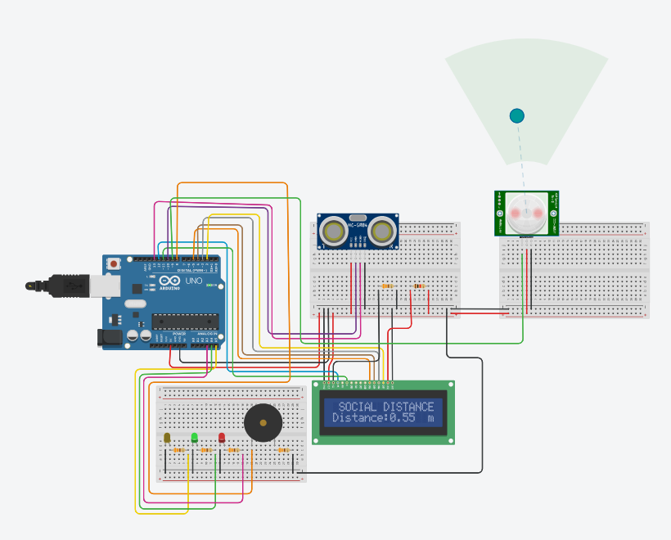

#### Figure 4.1.2 when PIR sensor in high condition

When the PIR sensor in a high state, the green LED will be turned on and will calculate the social distance. If the distance less than 100cm or 1m, the Piezo buzzer will be loud, and the red LED also will be turned on. All the things will be shown on LCD. The design was very suitable for the market or any public place that wants to ensure the social distancing between one person to another person.

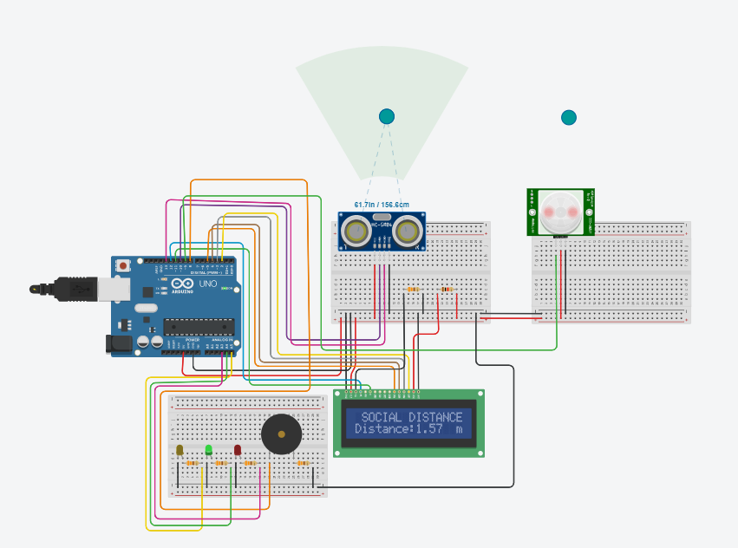

#### Figure 4.1.3 when PIR sensor in high state but social distance more than or equal 1m

When the PIR sensor in a high state, the green LED will be turned on and will calculate the social distance. If the distance more than 100cm or 1m, the Piezo buzzer will not be loud, and the red LED also will be turn off. All the things will be shown on LCD.

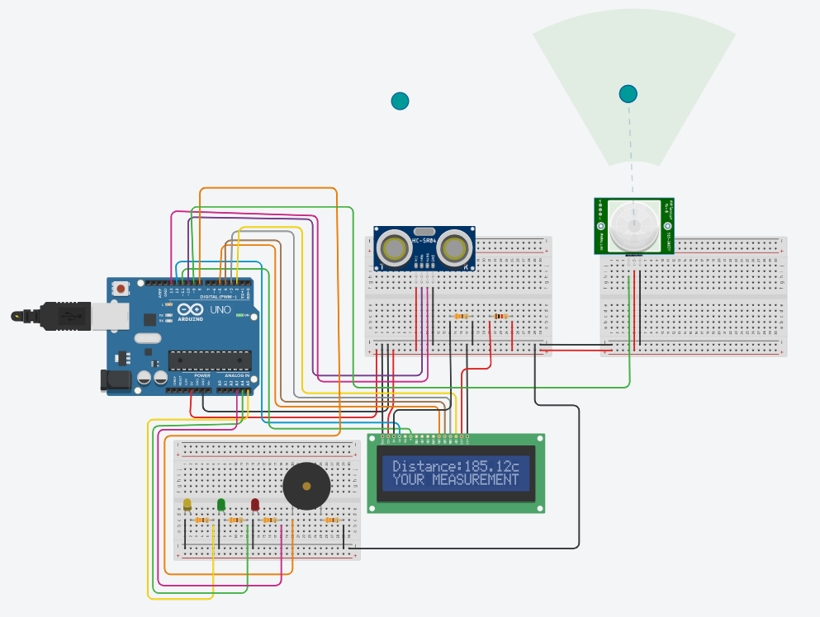

Figure 4.1.4 when PIR sensor in low condition.

When the PIR sensor in a low state, the LCD will only show measurement in a centimeter unit. And then, the yellow LED will be turned on. The design was suitable to measure anything except animals or humans [6].

### 4.1.2 Discussion

I have also had some challenges with the project as to when to calculate the echo and trigger. For the Echo pin on the Ultrasonic board, I need to calculate correctly to get the best value for centimeter and meter due to has absorbed an ultrasound of 40kHz that traveled the air, which might rebound to the module if there was an object or obstacle on its way [1]. Otherwise, I need to look at a lot of other research to know how to configure the trigger pin and echo pin in the Ultrasonic board.

The advantage of this project, the affordable worth estimates below RM 45.00. this product additionally straightforward to hold anyplace as well as for creating measurements within the slender place. Otherwise, an Arduino UNO is also less laid low with target materials, surfaces, and not affected by any color. After that, even over long operating distances, it also can detect objects.

The disadvantage of this project, the Ultrasonic Distance Sensor only can measure from 2cm to 400cm or 0.02m to 4m. Otherwise, when the surrounding temperature same as human temperature, the detection and sensitivity can drop significantly, and typically even a short failure will occur. Other than that, Passive infrared penetrating power is comparatively poor. Once the infrared light of the shape is blocked by some different objects in a human or animal body, it is not simply accepted by the signal, and typically it cannot be induced and then the button state will in the low signal state but the PIR sensor was failed to detect the human body.

Furthermore, the PIR sensor only can make the body detection approximately 10m from the sensor but the Ultrasonic Distance Sensor only can make detection around 0.02m until 4meter only. These disadvantages will make this circuit or project less efficient in certain situation.

#### 4.1.3 Proposed budget

|  |  |  |  |  |  |
| --- | --- | --- | --- | --- | --- |
| No. | Name | Version | Price Per Unit | Reference | Cost |
| 1. | Ultrasonic Distance Sensor | HC-SR04 | RM 4.85 x 1 | Shoppe | RM 4.85 |
| 2. | Arduino Uno | REV3 | RM 18.00 x 1 | Shoppe | RM 18.00 |
| 3. | Cable Connector | 4 Pin Female to Grove 4 Pin Cable | RM 2.36 x 3 | Arduino Store | RM 7.08 |
| 4. | 16x2 LCD | LCD1602 Serial IIC I2C | RM 11.30 x 1 | Shoppe | RM 11.30 |
| 5. | Piezo Buzzer (Beep Sound)  Car 12V Beep Piezo Electronic Buzzer Alarm 95DB Continuous Sound Beeper  MSOP | Shopee Malaysia | 95DB Piezoelectric Buzzer Alarm | RM 4.90 x 1 | Shoppe | RM 4.90 |
| 6. | PIR Motion Sensor | HC-SR501 | RM 4.50 x 1 | Shoppe | RM 4.50 |
| Total  (RM) |  |  |  |  | RM 50.63 |

# **Chapter 5**

## 5.1 Conclusion

So, what I have been doing with this project is measuring any object from an ultrasonic sensor and ensuring that I will get at least a 1 meter for social distancing, and then being able to stop the spread of the COVID-19 pandemic, as the government suggests. Distance measurement using Arduino UNO and an ultrasonic sensor contains a rebound or echo pin for a high distribution frequency after collision with an object. Based on the collision, I will obtain the sound velocity and travel time to obtain the accuracy of the distance of an object.

This project can assist all sectors of the industry or the market to ensure social distancing from human to human. For the measurement industry, this project minimizes the cost of purchasing a measurement tool because, according to my observation from the online platform, the price of measurement tools is very expensive compared to the Arduino UNO board.

From this project, I learned to complete the Arduino code through the library. And then, I also learned to calculate the ultrasound sensor module HC-SR04 frequency, which is to get the distance, I must multiply the speed of sound with the travel time as I explain in chapter 3.

# References

|  |  |
| --- | --- |
| [1] | C. H. N. Soni, C. H. Sarita, S. Maheshwari, B. K Sahu, B. Jain, G. Shrivastava, "Distance Measurement using Ultrasonic Sensor and Arduino," *International Journal of Engineering Science and Computing,* vol. 7, no. 3, pp. 5991-5992, 2017. |
| [2] | Dejan, "Ultrasonic Sensor HC-SR04 and Arduino Tutorial," How To Mechatronics, 24 November 2015. [Online]. Available: https://howtomechatronics.com/tutorials/arduino/ultrasonic-sensor-hc-sr04/. [Accessed 10 December 2020]. |
| [3] | Jsvester, "Simple Arduino and HC-SR04 Example," Instructables, 27 May 2019. [Online]. Available: https://www.sparkfun.com/products/15569. [Accessed 8 December 2020]. |
| [4] | "ARDUINO UNO REV3," Arduino Store, 15 October 2019. [Online]. Available: https://store.arduino.cc/usa/arduino-uno-rev3. [Accessed December 9 2020]. |
| [5] | "Hello World!," Arduino.cc, 15 February 2018. [Online]. Available: https://www.arduino.cc/en/Tutorial/LibraryExamples/HelloWorld#see-also. [Accessed 8 December 2020]. |
| [6] | M. A. B. M. RAMLI, "TINKERCAD," AUTODESK TINKERCAD, 25 NOVEMBER 2020. [Online]. Available: https://www.tinkercad.com/things/h36ECEXMkHK-final-projectde96562/editel. [Accessed 14 DECEMBER 2020]. |